Exercise 5: Configuring the Spring IoC Container

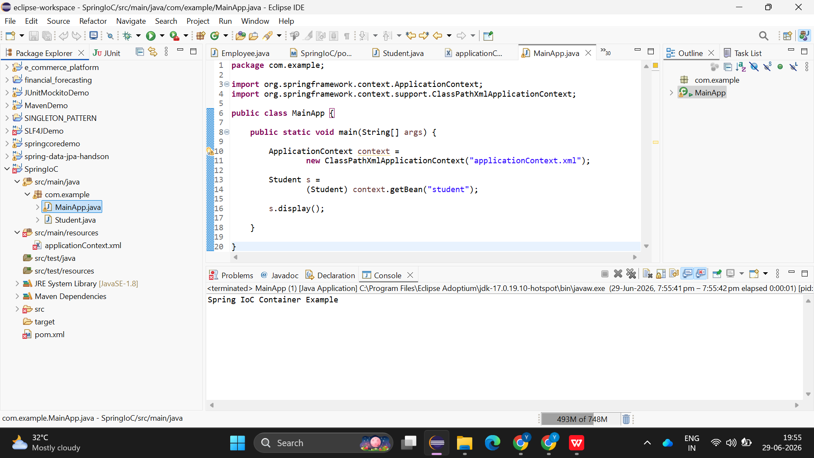

Exercise 7: Implementing Constructor and Setter Injection

